Zero discharge process for foil industry waste acid reclamation: Coupling of diffusion dialysis and electrodialysis with bipolar membranes
J. Membr. Sci., 2013, 432, pp 90–96 (1 April, 2013)
By Jin-Xia Zhuang, Qing Chen, Shun Wang, Wei-Ming Zhang*, Wei-Guo Song*, Li-Jun Wan, Kun-Song Ma, Chun-Nian Zhang
10.1016/j.memsci.2013.01.016 local fulltext
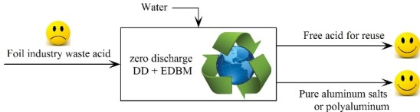
A zero discharge process was proposed to totally recover both acid and aluminum resource from the waste acid in foil industry. Diffusion dialysis (DD) was coupled with electrodialysis with bipolar membranes (EDBM) in this process, in which most of the free acid was first recovered by DD; and the resulting waste dialysate was further basified by EDBM, recovering aluminum resource and the rest of free acid. Through this process, all components in waste acid were recovered as valuable chemicals, resulting in zero discharge of dangerous effluents. This process is profitable in terms of cost analysis and significantly reduces the environmental burden of foil industry, enabling the foil industry to be more cost-effective, more environmental friendly and more sustainable.

